**FINAL Exam: DATABASE**

**WEP 2024**

**{3h 00}**

25 JAN 2023

**RULES:**

* Chatting and talking to other students is forbidden
* You are allowed to use PhpMyAdmin or VSCode or any other software. But it is not required
* Write (copy/paste) your answer below the question. Do not screenshot.

**HOW DO I SUBMIT THE EXAM?**

* Save this document as a yourfullname.PDF file
* In Google Classroom, attach this file to submit.

|  |  |
| --- | --- |
| **EXERCISES** | **POINTS** |
| THOERYS | 20 |
| EXERCISE 1 | 20 |
| EXERCISE 2 | 20 |
| EXERCISE 3 | 20 |
| EXERCISE 4 | 20 |
| EXERCISE 5 | 20 |
| **TOTAL** | **100** |

# Exercise 03 (20 points) Basic SQL Query

Write SQL query to create tables that have in Entity Relational Diagram (ERD) below:

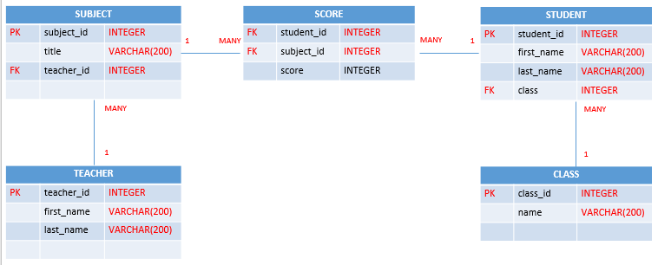

**Your Query:**

|  |
| --- |
| TEACHER:  CREATE TABLE TEACHERS (  Teacher_id int(11) NOT NULL AUTO_RENEMENT PRIMARY KEY,  First_name VARCHAR(20),  Last_name VARCHAR(20)  );  SUBJECT:  CREATE TABLE SUBJECTS (  Subject_id int(11) NOT NULL AUTO_RENEMENT PRIMARY KEY,  Title VARCHAR (100),  Teacher_id int(11),  FOREIGN KEY (teacher_id) REFERENCES TEACHERS(teacher_id)  );  CLASS:  CREATE TABLE CLASS(  Calss_id int(11) NOT NULL AUTO_RENEMENT PRIMARY KEY,  Name VARCHAR(20)  );  STUDENTS:  CREATE TABLE STUDENTS (  Student_id int(11) NOT NULL AUTO_RENEMENT PRIMARY KEY,  First_name VARCHAR(20),  Last_name VARCHAR(20),  Class_id (11),  FOREIGN KEY (Class_id) REFERENCES CLASS(Class_id)  );  SCORE:  CREATE TABLE SCORE(  Student_id int(),  Subject_id int(),  FOREIGN KEY (Student_id) REFERENCES STUDENTS(Student_id),  FOREIGN KEY (Subject_id) REFERENCES SUBJECTS(Subject_id),  Score int(100)  ); |

# Exercise 04 (20 points) SQL Query Select

***Important****: Import database name “database_final_exam.sql” into your databasae.*

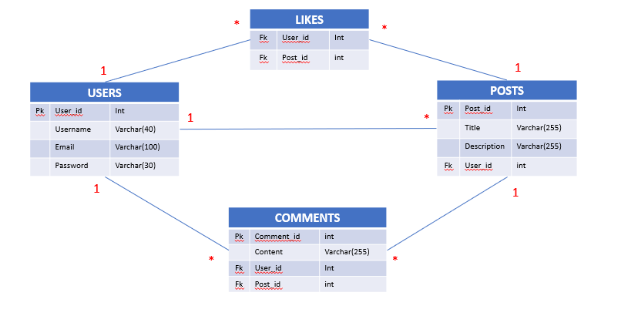

**Q1 – (10 POINTS):** Write a SQL statement to display all POSTS for the user named “**Rady Y**”

**Expected result:**

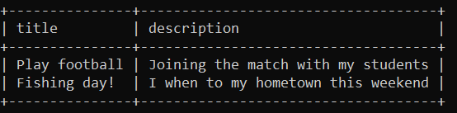

**Your Query:** SELECT title, description FROM posts where user_id=3;

|  |
| --- |
|  |

**Q2 – (10 POINTS):** Write a SQL statement to display the username of who likes on many posts.

**Expected result:**

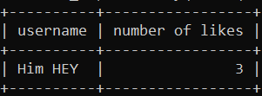

**Your Query**: select username, post_id from likes INNER JOIN users ON likes.user_id = users.user_id WHERE username ="Him HEY" AND post_id = 3;

|  |
| --- |
|  |